Effect of Enhanced Trackbed Support on Railway/Highway At-Grade Crossing Performance
Jerry G. Rose¹, Brett R. Malloy²

¹ Department of Civil Engineering, University of Kentucky, Lexington, KY
² Integrated Engineering, Lexington, KY

For over 30 years researchers at the University of Kentucky (UK) have performed railway trackbed research aimed at developing improved structural support for railway/highway at-grade crossings. Frequently replacing and rehabilitating railway/highway at-grade crossings is a major expense incurred by state transportation agencies as well as the railroad industry. An ideal crossing system is one that maintains a smooth surface and a stable highway/trackbed for a long period of time. This reduces maintenance costs as well as the number of inconvenient disruptions to highway and railway traffic.
A growing number of public agencies and railroad companies have mandated the use of asphalt underlayments on select crossings, normally on heavy traffic/tonnage crossings that have weak support, as evidenced by track pumping, ballast fouling, and track settlement. The report concludes by summarizing how eleven public agencies and railroad companies, spread across the United States, currently implement asphalt underlayment.

Design
This report documents the performance of 89 crossings, most of which are located in the State of Kentucky. Most of the crossings we evaluated varied in age from 10-15 years; however some ranged in age up to 30 years. Each of these crossings contains a layer of asphalt underneath the ballast; this trackbed system is known as an “asphalt underlayment” trackbed. This high-quality substructure provides increased load-carrying capacity for trains and highway vehicles by confining the ballast and providing subgrade waterproofing to the jointly-used crossing area common to both modes of traffic. All of the asphalt underlayments were installed at crossings that had historically exhibited poor performance and relatively brief service lives.
Figure 1. Two Types of Asphalt Support Structures used for Railway/Highway At-Grade Crossings

Field Performance
These crossings have performed excellently since having asphalt underlayments installed. Their performance improved significantly over what was attained with conventional all-granular trackbed designs. Critically, the use of asphalt underlayments in the crossing substructures has provided increased levels of performance and extended the useful lives of crossings irrespective of traffic volumes and loading magnitudes. The crossing surface material chosen has little effect on subsequent performance of crossings as long as adequate structural support is provided.
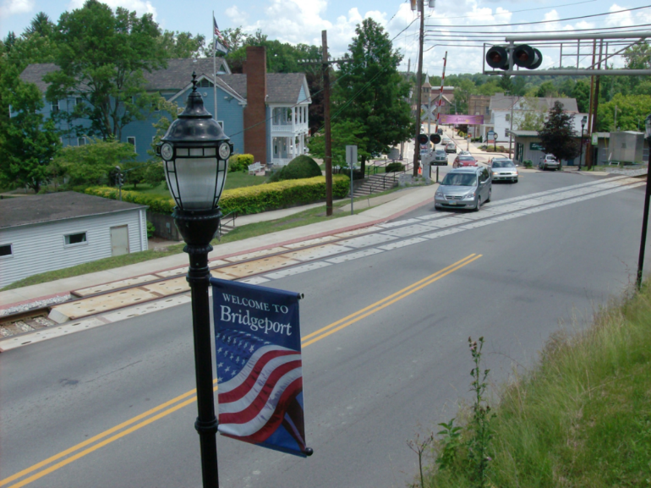
Figure 2. Recently Rehabilitated Railway/Highway At-Grade Crossing
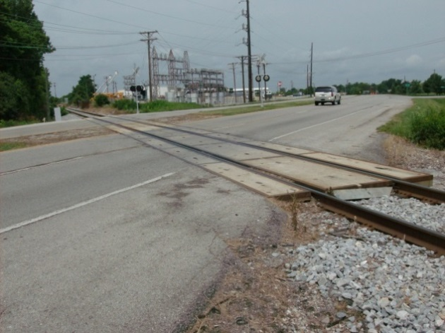
Figure 3. Perfectly Performing Premium Crossing Surface after 8 Years
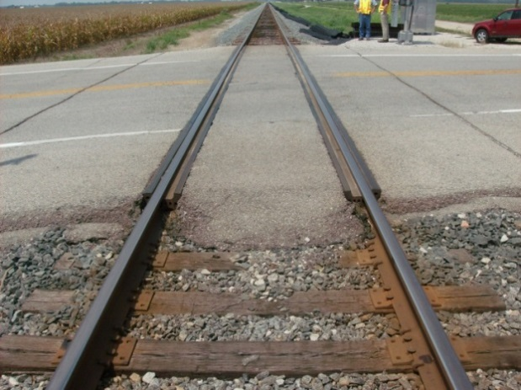
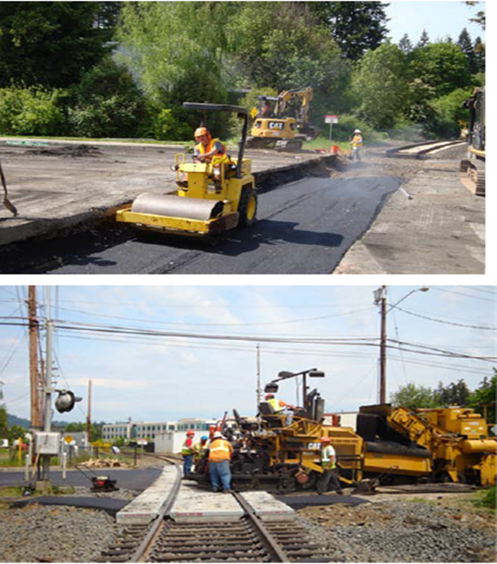
Figure 4. Perfectly Performing Traditional Crossing after 10 years
Figure 5. Placing Asphalt Trackbed Support Layer (top) and Paving Asphalt Highway Approaches (bottom)

Summary and Conclusion
Adopting asphalt underlayments enables government agencies and railroad companies to use more economical crossing surface materials with confidence, and with the knowledge that doing so will not shorten a crossing’s service life. No crossing failures due to inadequate support, such as excessive settlement or mud pumping, have been noted for any of the 89 crossings evaluated as part of this study.
When crossings are properly designed and granted adequate support, irrespective of the crossing surface used – whether a more economical or more premium material – asphalt underlayments extend their service life and boost performance. As such, the type of crossing surface material appears to have little effect on subsequent performance and service life of crossings that have adequate structural support and an efficient drainage network. Improved performance and longer service life have been achieved under varying railway and highway traffic volumes and loading magnitudes. The geometric design of the roadway near crossings should minimize the possibility of highway vehicles experiencing abrupt changes in vertical grades. When sudden changes in grade are present, they increase impacts to the crossing surface, which can lead to its premature failure, particularly on heavy-traffic roadways with concrete crossing surfaces. The effect is more pronounced for crossings possessing inadequate structural support. Careful design, along with the use of asphalt underlayments, holds great promise for enhancing the robustness of railway-highway at-grade crossings.

Reference
[1]. Rose, J G., and B. Malloy, Research Report KTC -14-16/SPR-452-13-1F. “Effect of Enhanced Trackbed Support on Railway/Highway At-Grade Crossing Performance,” Kentucky Transportation Center, University of Kentucky, December, 2014, 180 pages.
The authors would like to thank the National University Rail (NURail) Center, a US DOT-OST Tier 1 University Transportation Center for sponsoring this study.

